***DATA ANALYST***

**Project Report**

**On -**

**Company HR Data Analyst Report**

By

SHUBHANGI SATALE

**TABLE OF CONTENT**

|  |  |  |
| --- | --- | --- |
| **SR.NO** | **DESCRIPTION** | **PAGE NO.** |
| 1 | Summary | 3 |
| 2 | Scope of the project | 4 |
| 3 | Objectives of the project | 5 |
| 4 | Project entities | 6,7,8 |
| 5 | Methodology | 9 |
| 6 | Scheme | 10 |
| 7 | Business Question’s | 11,12 |
| 8 | Key findings | 13 |

**Summary**

The Company HR Data Analyst Report project aims to develop and deploy a comprehensive database management system for the company's HR department, gathering and scrutinizing HR data to glean actionable insights and generate reports on employee demographics, departmental productivity, and compensation patterns, with objectives to design and implement a robust relational database management system, collect and analyse HR data, identify trends and patterns, and develop intuitive data visualization dashboards, delivering a fully implemented system, comprehensive reports, and a presentation showcasing key findings and trends, all within a 10-week timeframe using SQL software, data visualization tools, HR data sources, computer hardware, and internet connectivity.

**Project Scope**

1. **Database Design and Implementation**: Create a relational database management system using SQL, including designing a database schema, creating tables, and defining relationships.
2. **HR Data Collection and Storage**: Gather HR data from various sources, such as HR systems, payroll systems, and performance management systems, and store it in a centralized database.
3. **HR Data Analysis and Insights**: Use SQL queries and data analysis techniques to extract insights from HR data, including employee information, departmental performance, and salary trends.
4. **Trend Identification and Pattern Analysis**: Apply data visualization and statistical techniques to identify trends and patterns in HR data, supporting informed business decisions.
5. **Data Visualization Dashboard Development**: Create interactive dashboards using data visualization tools to present findings and trends in HR data to stakeholders.
6. **Data Governance and Compliance**: Establish policies and procedures for data management, security, and compliance, ensuring adherence to regulatory requirements.
7. **Data Quality Metrics and Monitoring**: Develop metrics to measure data quality and monitor data quality on an ongoing basis, ensuring data accuracy and reliability.
8. **Training and Support for HR Stakeholders**: Provide training and support to HR stakeholders on using the database and data visualization dashboards, ensuring effective adoption.

**Project Objectives**

* 1. **Database Design and Implementation**: Create a robust relational database management system for HR data, encompassing schema design, table creation, and relationship definition.
  2. **HR Data Collection and Analysis**: Gather HR data from diverse sources, apply statistical techniques, and extract actionable insights to inform business decisions.
  3. **Trend Identification and Pattern Analysis**: Utilize data visualization and statistical techniques to uncover trends and patterns in HR data, driving strategic decision-making.
  4. **Data Visualization Dashboard Development**: Design interactive dashboards using data visualization tools, presenting HR data insights and trends to stakeholders.
  5. **Data**-Driven Recommendations: Leverage data analysis and insights to propose HR process enhancements, optimizing efficiency and effectiveness.
  6. **Data Governance and Compliance**: Establish and maintain policies and procedures for data management, security, and compliance, ensuring adherence to regulatory requirements.
  7. **Data Quality and Integrity**: Ensure data accuracy, completeness, and consistency through rigorous validation and cleansing processes.

**Project Entities**

1. **Employees**: An employee is an individual who works for the company.

* Attributes:
  + Employee ID (unique identifier)
  + Name
  + Date of birth
  + Job title
  + Department
  + Location
  + Manager
  + Hire date
  + Salary
  + Relationships:
  + An employee belongs to one department.
  + An employee has one manager.
  + An employee can have multiple job histories.

1. **Departments:** A department is a functional unit within the company.
   * Attributes:
   * Department ID (unique identifier)
   * Department name
   * Description
   * Relationships:
   * A department can have multiple employees.
   * A department belongs to one location.

3**. Locations**: A location is a physical site where the company operates.

* + Attributes:
  + Location ID (unique identifier)
  + Location name
  + Address
  + City
  + State
  + Country
  + Relationships:
  + A location can have multiple departments.
  + A location belongs to one region.

**4. Job Histories**: A job history represents an employee's previous job assignments.

* + Attributes:
  + Job history ID (unique identifier)
  + Employee ID
  + Job title
  + Department
  + Location
  + Start date
  + End date
  + Relationships:
  + A job history belongs to one employee.

**5. Managers:** A manager is an employee who supervises other employees.

* + Attributes:
  + Manager ID (unique identifier)
  + Name
  + Department
  + Location
  + Relationships:
* A manager can supervise multiple employees.

**6. Jobs**: A job represents a specific role within the company.

* + Attributes:
  + Job ID (unique identifier)
  + Job title
  + Job description
  + Department
  + Location
  + Relationships:
* A job can have multiple employees.

**7. Regions**: A region represents a geographic area where the company operates.

* + Attributes:
  + Region ID (unique identifier)
  + Region name
  + Relationships:
  + A region can have multiple locations.

**8. Countries:** A country represents a sovereign nation where the company operates.

* + Attributes:
  + Country ID (unique identifier)
  + Country name
  + Relationships:
  + A country can have multiple regions.

**Methodology**

**1. Data Collection**:

* 1. HR data will be collected from various sources, including employee records, departmental reports, and job history documents.
  2. Data will be stored in a relational database management system using SQL.

**2. Data Analysis:**

* 1. SQL queries will be used to analyse HR data and provide insights and reports on employee information, departmental performance, and salary trends.
  2. Data visualization techniques will be used to present findings and trends in HR data.

**3. Data Visualization**:

* 1. Data visualization dashboards will be developed using data visualization software
  2. Dashboards will be used to present findings and trends in HR data.

**After Normalization ER Diagram**

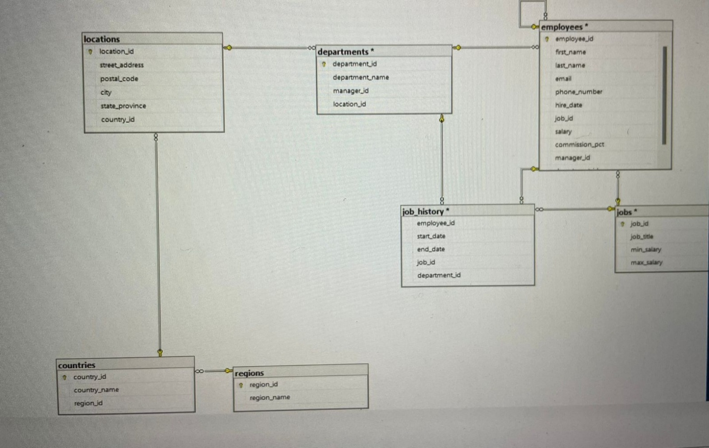

**Business Questions**

**Que1: What is each employee's department?**

select e.employee_id,e.f_name,e.last_name, d.department_name

from employees3 e join departments d

on e.department_id=d.department_id;

**Que2: Get all the managers and employees who manage it.**

select m.manager_id,m.first_name,m.last_name,e.employee_id,e.f_name,e.last_name

from managers m left join employees3 e

on m.manager_id=e.manager_id;

**Que3: How many employees does each manager manage?**

select m.manager_id,m.first_name,m.last_name,count(e.employee_id) as employee_count

from managers m left join employees1 e

on m.manager_id=e.manager_id

group by m.manager_id,m.first_name,m.last_name;

**Que4: How many employees are there in each job title?**

select j.job_title,count(e.employee_id) as employee_count

from jobs j left join employees3 e

on j.job_id=e.job_id

group by j.job_title;

**Que5: Compare employee salaries with the salaries set by the company.**

select e.employee_id,e.first_name,e.last_name,e.salary,j.min_salary,j.max_salary,

case

when e.salary<j.min_salary then 'below minimum'

when e.salary >j.max_salary then 'above maximum'

else 'within range'

end as salary_comparison

from employees3 e

join jobs j

on e.job_id=j.job_id;

**Que6: Get information about the number of employees and salary in each department.**

select d.department_name,count(e.employee_id) as employee_count,sum(e.salary) as total_salary,avg(e.salary) as average_salary

from departments d

left join employees3 e

on d.department_id=e.department_id

group by d.department_name;

**Que7: How many employees are there in each city and what is their average salary?**

select l.city,count(e.employee_id) as employee_count,avg(e.salary) as average_salary

from locations l

left join departments d

on l.location_id=d.location_id left join employees1 e on d.department_id=e.department_id group by l.city;

**Final Overall Analysis**

1. Employee department information was retrieved.

2. Manager and employee relationships were analysed.

3. Employee counts and salaries were analysed by department and job title.

4. Salary comparisons were made with company-set salaries.

5. Data cleaning and maintenance tasks were performed.

**Future Scope**

The future scope of this project is that this will be used for designing a dashboard using data visualization tools

PowerBI and automating salary slips of employee using programming language like Python which will helpful in

company growth and overall progress of company.